ADHD

Attention Deficit Hyperactivity Disorder

AIDS

Acquired ImmunoDeficiency Syndrome

ASL

American Sign Language

ATC

Air Traffic Controller

ATM

Automated Teller Machine

ATV

All Terrain Vehicle

BBC

British Broadcasting Corporation

BLM

Bureau of Land Management/Black Lives Matter

BLT

Bacon, Lettuce, Tomato

BYOB

Bring Your Own Beverage

CAPTCHA

Completely Automated Public Turing Test to Tell Computers and Humans Apart

CDL

Commercial Drivers License

CIA

Central Intelligence Agency

COVID

Corona Virus Disease

CPR

CardioPulmonary Resuscitation

CPU

Central Processing Unit

DARE

Drug Abuse Resistance Education

DIY

Do It Yourself

DMV

Division of Motor Vehicles

DOB

Date of Birth

DVD

Digital Video Disk

EMT

Emergency Medical Technician

ESPN

Entertainment and Sports Programming Network

EST

Eastern Standard Time

ETA

Estimated Time of Arrival

FAA

Federal Aviation Administration

FAQ

Frequently Asked Questions

FBI

Federal Bureau of Investigation

FDA

Food and Drug Administration

FFA

Future Farmers of America

FYI

For Your Information

GED

General Educational Diploma

GIF

Graphics Interchange Format

GPS

Global Positioning System

GRE

Graduate Record Examination

HEPA

High Efficiency Particulate Air (filter)

HDTV

High Definition Television

ICU

Intensive Care Unit

IRS

Internal Revenue Service

ISS

International Space Station

JPEG

Joint Photographic Experts Group

KGB

Komitet Gosudarstvennoy Bezopasnosti

KISS

Keep It Simple Stupid

LAPD

Los Angeles Police Department

LED

Light Emitting Diode

LIDAR

Light Detection and Ranging

LNT

Leave No Trace

MADD

Mothers Against Drunk Driving

MLB

Major League Baseball

MPH

Miles Per Hour

MRE

Meal Ready to Eat

NAFTA

North American Free Trade Agreement

NASA

National Aeronautics and Space Administration

NATO

North Atlantic Treaty Organization

NBA

National Basketball Association

NFL

National Football League

NHL

National Hockey League

NOAA

National Oceanic and Atmospheric Administration

NPR

National Public Radio

NPS

National Park Service

NYPD

New York Police Department

PBJ

Peanut Butter & Jelly

PDF

Portable Document Format

PIN

Personal Identification Number

POTUS

President of the United States

PPE

Personal Protective Equipment

PTA

Parent Teacher Association

PTSD

Post Traumatic Stress Disorder

RADAR

Radio Detection and Ranging

RAM

Random Access Memory

RIP

Rest in Peace/Requiescat in pace

RNA

Ribonucleic Acid

ROYGBIV

Red Orange Yellow Green Blue Indigo Violet

RSVP

Répondez s'il vous plaît

SAR

Search and Rescue

SAT

Scholastic Aptitude Test

SCUBA

Self-Contained Underwater Breathing Apparatus

SIM

Subscriber Identity Module

SONAR

Sound Navigation Ranging

SUV

Sport Utility Vehicle

SWAT

Special Weapons and Tactics

TASER

Tom Swift and His Electric Rifle

TBA

To Be Announced

TGIF

Thank Goodness It's Friday

TLC

Tender Loving Care

UFO

Unidentified Flying Object

UPS

United Parcel Service

USA

United States of America

USPS

United States Postal Service

VFW

Veterans of Foreign Wars

VHF

Very High Frequency

VIP

Very Important Person/Volunteer in the Park

WHO

World Health Organization

WWW

World Wide Web

YMCA

Young Men's Christian Association

ZIP

Zone Improvement Plan

Newspaper
Headline


Vacation/
Travel


Nature
Related


Food &
Drink


Military


Education


Sports


Rhyme if
You Can

Something Your Grandma Would Say
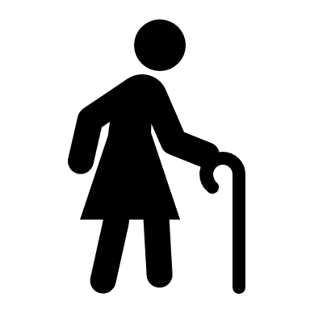

Holiday
Add “Day” to the end


Official
Sounding


Youngest Player’s Choice


Something You
Would Text


Country-Western
Song Title


Health & Fitness


Animals


Fantasy



Science-Fiction



Clothing/
Apparel


Sports


